A.P. WORLD HISTORY 2018-2019
Mrs. Alexandra Thiessen

INTRODUCTION: Welcome to AP World History and the 2018-2019 school year! Please use this course syllabus to understand the scope and sequence of this course as well as policies and procedures.

COURSE AIMS: This is a college-level course designed for high school sophomores. This course is designed to be challenging and to move beyond simple historical knowledge and comprehension. Students will use their historical understanding to build the following skills: analysis, synthesis, periodization, and contextualization.

COURSE GRADING: As adopted uniformly by the Bellevue West Social Studies Department, grading will follow a 70%-30% grade distribution. Summative assessments (such as Periods 1-6 examinations and Semester Final examinations) will contribute to 70% of a students’ course grade. Formative assessments (such as ongoing assessments, in-class tasks, and homework) will contribute the other 30% of a students’ course grade.

COURSE MATERIALS: Your textbook is “Traditions and Encounters” by Bentley, et. al. and is necessary to complete all reading assignments. Your supplemental review book is the AMSCO World History book. You will need a binder to keep class materials organized. You may elect two have two binders; one for current information to bring daily to class and one to organize your past units. Organization is critical to your success! You will have reading guides, lecture notes, quizzes, review guides, essays and assorted readings throughout the year. You are responsible for keeping organized and maintaining all materials the entire school year as the AP Test and Course Final are cumulative over the school year.

HOMEWORK: Because of the sheer scope of this course, work outside of class is essential to student success. You can expect to be doing the following outside of class time and on a regular basis: reading the textbook and supplemental resources, completing reading guides for textbook chapters, completing review guides, writing essays, and studying for quizzes, tests, and the AP exam. Specific homework due dates will be provided on the course calendar. Plan ahead for these given assignments and complete the tasks on schedule. Class work will be focused on interactive lecture, activities, essay writing, and review. If homework is not completed outside of the class, you will be unable to participate effectively in class work. Late work may be accepted for reading guides until one week prior to the end of the semester for up to 80% credit. Daily in-class work for the unit must be complete by the end of the unit (by the Period Test date). Homework over school breaks (Winter Break, Spring Break, etc.) will not be accepted late for any reason.

QUIZZES AND TESTS: Quizzes will be scheduled regularly on the course calendar. Quizzes will be comprehension quizzes over specific chapters and will be made up of multiple-choice and essay questions. Quizzes are formative; they are meant to judge what a student knows at that moment and demonstrate areas of improvement before the Period summative test. Students should review the information they miss and ask clarification as needed. Students may complete Quiz Redos for up to 80% credit. Quiz Redos must be taken during GPS only and within one week of the original test date. The formative quizzes, as well as the reading, homework, and class work will prepare students for their Period test. The Period test will be taken over two-three days, including portions dedicated to Multiple-Choice, Short-Answers, and Long Essay exams. All portions of the exam are weighted equally and will both be summative assessments. Summative assessments may be retaken after relearning as occurred once for up to 70% credit within two weeks of the original tests’ feedback.

EXPECTATIONS: Expectations will be very high. As an AP Course, this will be both challenging and rewarding. Students are expected to put their best effort into preparing for the AP Exam throughout the entire course. This course is not for slackers or procrastinators- you must be diligent in reading and studying outside of class. Except for extreme circumstances, students may not drop the course after the first quarter. Attendance is expected daily. If you are absent, you are responsible for looking on the calendar and the website for any necessary assignments and completing the tasks on the assigned day regardless. Absences for school-related activities must be arranged in advance of the absence, per district policy.

CONTACT INFORMATION: In this class, communication is essential. Please feel free to contact me at any time via e-mail at alexandra.thiessen@bpsne.net and I will try to respond in a timely manner. Additional information for the course may be found on the class website by going to www.mrsthiessensclass.weebly.com. This website will include all course materials, including Power Points and handouts. Resources will also be found on the class Schoology page. You are required to sign up for Remind to receive text messages or e-mails about upcoming important dates and information.

SPECIAL NOTE: You the student, as a whole person, is my top priority as a teacher. Due to the rigor of the course, and the fact that students are often taking multiple rigorous courses on top of other school and community activities, a high degree of stress to develops. While stress is normal, it should never be suffocating. Students wellbeing matters more than any test score could ever mean. If the workload of the course becomes overwhelming, students should talk to me individually so that we can strategize how to make things work while also accomplishing the objectives of the course.

What is AP World History?
aka. What Have I Gotten Myself Into!?

What is “AP”? AP stands for Advanced Placement. That means that is course is aligned with the AP College Board, an organization that has created the content and assessment for this course. Students can take AP courses in a variety of levels and subjects. As sophomores, this is the first foray into the world of AP.

What is the “AP Test”? The AP World History Exam is a very challenging nationwide test to assess whether you as an AP student truly understand the material covered in the course description established by the College Board, at the level of a successful 100-level college student. Throughout the course, we will be preparing for the AP Test and everything will culminate with the AP test. On May 17th, the AP World History test will be available for students to complete. Because there is a cost involved, students are highly encouraged, but not required, to take this exam

What is on the AP Test? The AP Test consists of a section of multiple-choice, short-answer questions, long-essay question and a document-based question. The charts below describe the makeup of the exam, and the distribution by time and region.
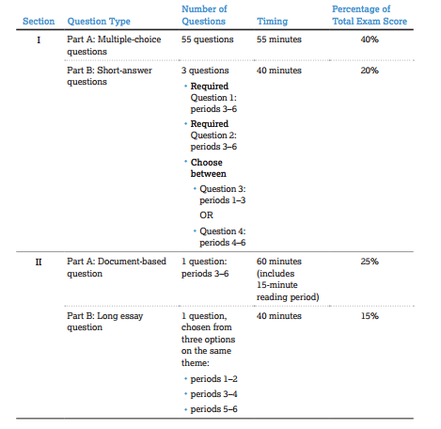
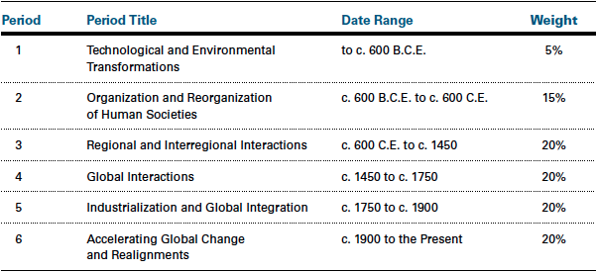

What do I need to get on the AP Test for college credit? Grades are given on a scale of 1-5, a score of 1 being the lowest and 5 being the highest. Most schools will generally accept scores of 3-5 for credit, while some will only accept scores of 4-5. Check the AP College Board website for the specific school in which you are interested.
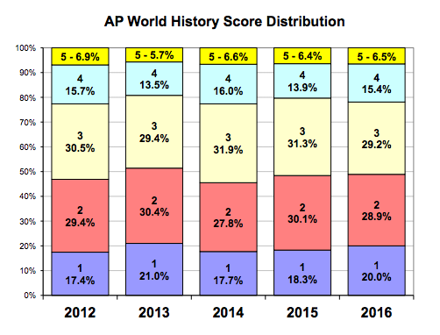
How does this class differ from Regular World History? Both courses will earn you the exact same World History credit and are taught by very competent instructors. Here is a little overview on both classes:
AP WORLD:
- Covers from the beginning of human history (about 8000
BCE) to current issues.
- We will read our textbook outside of class, from cover-to-cover by the end of the course.
- Homework, quizzes, and tests are organized and scheduled well in advance.
- Advanced learners allow us to go into more higher-level discussions, activities, and assignments. Less “rote” understanding.
- Ability to earn college credit with the successful completion of the AP World History test in May. A “bonus” point is earned on your GPA for taking an advanced course.
- More intense preparation for future Advanced or Advanced Placement courses and college courses.

REGULAR WORLD:
- Covers from the Renaissance (about 1400s) to current issues.
- We will not check out a textbook for the class.
- Homework, quizzes, and tests are scheduled to change to meet the needs of a variety of learners.
- A mixture of learners ensures we must meet the needs of all learners and therefore may go at a slower pace.
- No ability to earn college credit while in high school and no “bonus” point on your GPA.
- Will also be prepared for upper-level and college-ready skills.
