Practice DBQ

Directions: Question 1 is based on the accompanying documents. The documents have been edited for the purpose of this exercise.

In your response you should do the following.
- Respond to the prompt with a historically defensible thesis or claim that establishes a line of reasoning.
- Describe a broader historical context relevant to the prompt.
- Support an argument in response to the prompt using at least six documents.
- Use at least one additional piece of specific historical evidence (beyond that found in the documents) relevant to an argument about the prompt.
- For at least three documents, explain how or why the document’s point of view, purpose, historical situation, and/or audience is relevant to an argument.
- Use evidence to corroborate, qualify, or modify an argument that addresses the prompt.

- Using the documents and your knowledge of world history, evaluate the extent to which the Cold War between the United States and the Soviet Union affected other nations and/or regions of the world in the period 1945-1989.

Document 1

Source: Sook Nyul Choi, Year of Impossible Goodbyes, Houghton Mifflin Company

…Our freedom and happiness did not last long. In June 1950, war broke out. North Korean and Communist soldiers filled the streets of Seoul, and were soon joined by Chinese Communist troops. Russian tanks came barreling through. In the chaos, many more North Korean refugees made their way to Seoul. Theresa and the other nuns finally escaped, and made their way to our house. They told us that the Russians and Town Reds had found out about Kisa’s and Aunt Tiger’s other activities. They died as all “traitors” did. They were shot with machine guns, and then hanged in the town square to serve as a lesson to others. We never heard any further news about the sock girls, or about my friend Unhi. I still wonder if they are alive in the North.

Document 2

Source: Statement by Secretary of State Dean Rusk, August 13, 1961

The authorities in East Berlin and East Germany have taken severe measures to deny to their own people access to West Berlin. These measures have doubtless been prompted by the increased flow of refugees in recent weeks. The refugees are not responding to persuasion or propaganda from the West but to the failures of communism in East Germany. These failures have created great pressures upon communist leaders who, in turn, are trying to solve their own problems by the dangerous course of threats against the freedom and safety of West Berlin. The resulting tension has itself stimulated flights from the East.

Having denied the collective right of self-determination to the peoples of East Germany, communist authorities are now denying the right of individuals to elect a world of free choice rather than a world of coercion. The pretense that communism desires only peaceful competition is exposed; the refugees, more than half of whom are less than 25 years of age, have “voted with their feet” on whether communism is the wave of the future.

Document 3

Source: Klaus Lehnartz, Berlin: Bundesregierung, August 16, 1961

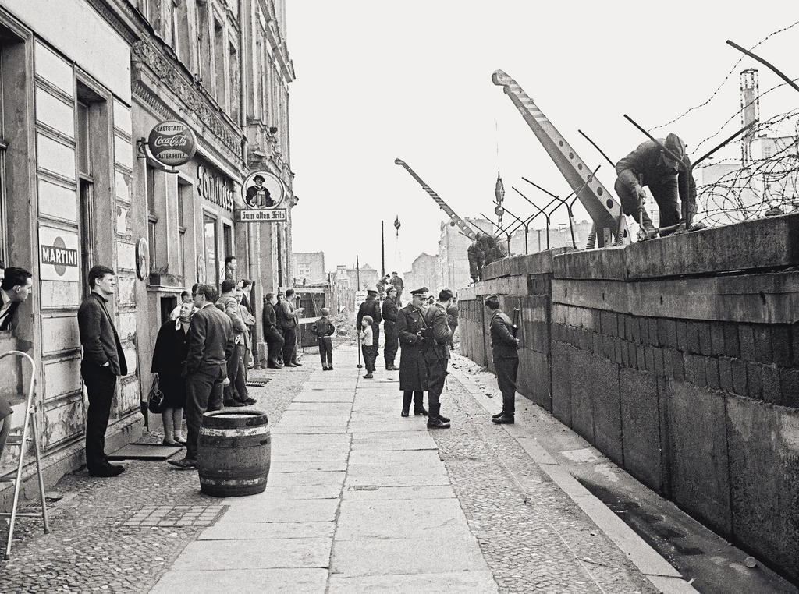

Document 4

Source: John F. Kennedy, Proclamation 3447—Embargo on All Trade with Cuba, February 3, 1962
Whereas the Congress of the United States, in section 620(a) of the Foreign Assistance Act of 1961 (75 Stat. 445), as amended, has authorized the President to establish and maintain an embargo upon all trade between the United States and Cuba; and
Whereas the United States, in accordance with its international obligations, is prepared to take all necessary actions to promote national and hemispheric security by isolating the present Government of Cuba and thereby reducing the threat posed by its alignment with the communist powers:
Now, Therefore, I, John F. Kennedy, President of the United States of America, acting under the authority of section 620(a) of the Foreign Assistance Act of 1961 (75 Stat. 445), as amended, do
1. Hereby proclaim an embargo upon trade between the United States and Cuba in accordance with paragraphs 2 and 3 of this proclamation.
2. Hereby prohibit, effective 12:01 A.M., Eastern Standard Time, February 7, 1962, the importation into the United States of all goods of Cuban origin and all goods imported from or through Cuba; and I hereby authorize and direct the Secretary of the Treasury to carry out such prohibition, to make such exceptions thereto, by license or otherwise, as he determines to be consistent with the effective operation of the embargo hereby proclaimed, and to promulgate such rules and regulations as may be necessary to perform such functions…

Document 5

Source: June 19, 1968, Pravda, official newspaper of the Soviet Communist Party, condems the new political course and the liberalization measures taken in Czechoslovakia during the ‘Prague Spring.’

The situation is such that the threat to the foundations of socialism in Czechoslovakia poses a threat to the vital interests of all socialist nations. It is the historical responsbility of all communists from socialist nations to ensure that the revolutionary victories achieved thus far should not be forfeited. Each of the fraternally united parties is answerable not only before its own working class and its people, but before the international working class and the global communist movement, and can not shirk any of the responsibilities that implies. Therefore we must be united and show solidarity in defending socialism, our security, and the international position of the entire socialist community. Out of international duty, delegates at the Warsaw meeting, on behalf of the Central Committees of their communist and labour parties appealed to the Central Committee of the Czechoslovak Communist Party to defend the power of the working classes and all workers, and to protect socialist achievements in Czechoslovakia. This required a decisive and courageous strike against the right-wing anti-socialists, and the mobilization of all means of defense at the socialist states’ disposal...

Document 6

Source: Statement by the signatories of the Warsaw Pact, December 2, 1970

The German Democratic Republic, the People’s Republic of Bulgaria, the People’s Republic of Hungary, the People’s Republic of Poland, the Socialist Republic of Romania, the Czechoslovak Socialist Republic and the Union of Soviet Socialist Republics, represented at the meeting of the Warsaw Treaty Political Consultative Committee in Berlin, have reviewed the development of the situation in Indo-China.

The United States of America has recently committed new acts of aggression against the Democratic Republic of Vietnam by launching massive attacks against its territory. These arrogant acts of American imperialism have generated deep outrage all over the world. Once again, the USA is showing its contempt for all generally accepted norms in relations between sovereign states, even going so far as to break its own promises…The continuation of the criminal war in South Vietnam, the extension of the armed intervention in Laos, the contempt for Cambodia’s neutrality and the aggression against it, together with the new air raids on the Democratic Republic of Vietnam, are all links in the same chain and elements of a policy designed to suppress the national liberation movement, to impose a brutal imperialist diktat and to use armed force to make these nations comply with the demands of imperialism…

The American imperialist attempts to break the will of the Vietnamese people and to intimidate and subjugate them have failed. US policy has met with one of its greatest defeats. The more the USA extends its intervention, the more the brave people of Vietnam, supported by their Socialist sister countries and all the forces of liberty, will stiffen their resistance…

Document 7

Source: President Jimmy Carter, Address to the Nation on the Soviet Invasion of Afghanistan, January 4, 1980

Recently, there has been another very serious development, which threatens the maintenance of the peace in Southwest Asia. Massive Soviet military forces have invaded the small, nonaligned, sovereign nation of Afghanistan, which had hitherto not been an occupied satellite of the Soviet Union. Fifty thousand heavily armed Soviet troops have crossed the border and are now dispersed throughout Afghanistan, attempting to conquer the fiercely independent Muslim people of that country.

The Soviets claim, falsely, that they were invited into Afghanistan to help protect that country from some unnamed outside threat. But the President, who had been the leader of Afghanistan before the Soviet invasion, was assassinated—along with several members of his family—after the Soviets gained control of the capital city of Kabul. Only several days later was the new puppet leader even brought into Afghanistan by the Soviets.
This invasion is an extremely serious threat to peace because of the threat of further Soviet expansion into neighboring countries in Southwest Asia and also because such an aggressive military policy is unsettling to other peoples throughout the world.

This is a callous violation of international law and the United Nations Charter. It is a deliberate effort of a powerful atheistic government to subjugate an independent Islamic people.
We must recognize the strategic importance of Afghanistan to stability and peace. A Soviet-occupied Afghanistan threatens both Iran and Pakistan and is a steppingstone to possible control over much of the world's oil supplies.

