Period 3 Timed LEQ
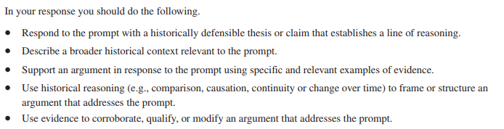

1. In the period 600 CE – 1450 CE, cross-cultural exchanges were fostered by the intensification of existing, or the creation of new, networks of trade and communication.
Develop an argument that examines the impact of cross-cultural exchanges between 600 CE and 1450 CE.

