AP WORLD HISTORY
Period 3 Take Home DBQ Essay

Directions: Question 1 is based on the accompanying documents. The documents have been edited for the purpose of this exercise.
In your response you should do the following.
- Respond to the prompt with a historically defensible thesis or claim that establishes a line of reasoning.
- Describe a broader historical context relative to the prompts.
- Support an argument in response to the prompt using all of the documents.
- For at least three documents, explain how or why the document’s point of view, purpose, historical situation, and/or intended audience is relevant to an argument.
- Use at least one additional piece of specific historical evidence beyond the examples found in the documents.
- Use evidence to corroborate, qualify, or modify an argument that addresses the prompt to create a highly organized and analytical essay that might include one or more of the following techniques:
- Explaining nuance of an issue by analyzing multiple variables
- Explaining both similarity and difference, or explaining both continuity and change, or explaining multiple causes, or explaining both cause and effect
- Explaining relevant and insightful connections within and across periods
- Confirming the validity of an argument by corroborating multiple perspectives across themes
- Qualifying or modifying an argument by considering diverse or alternative views or evidence

Prompt: Evaluate the extent to which the spread of Buddhism transformed Chinese society between 350 C.E. and 900 C.E.

Document 1
Source: Zhi Dun, Chinese scholar, author, and confidant of Chinese aristocrats and high officials during the period when northern China was invaded by central Asian steppe nomads, circa 350 C.E.

Whosoever in China, in this era of sensual pleasures, serves the Buddha and correctly observes the commandments, who recites the Buddhist Scriptures, and who furthermore makes a vow to be reborn without ever abandoning his sincere intention, will at the end of his life, when his soul passes away, be miraculously transported thither. He will behold the Buddha and be enlightened in his spirit, and then he will enter Nirvana.*

*Nirvana: the extinction of desire and individual consciousness

Document 2
Source: Anonymous Chinese scholar, “The Disposition of Error,” China, circa 500 C.E.

Question: If Buddhism is the greatest and most venerable of ways, why did the great sages of the past and Confucius not practice it? In the Confucian Classics no one mentions it. Why,then, do you love the Way of the Buddha and rejoice in outlandish arts? Can the writings of the Buddha exceed the Classics and commentaries and beautify the accomplishments of the sages?

Answer: All written works need not necessarily be the words of Confucius. To compare
the sages to the Buddha would be like comparing a white deer to a unicorn, or a swallow to a phoenix. The records and teachings of the Confucian classics do not contain everything. Even if the Buddha is not mentioned in them, what occasion is there for suspicion?

Question: Now of happiness there is none greater than the continuation of one’s line, of
unfilial conduct there is none worse than childlessness. The monks forsake wives and children, reject property and wealth. Some do not marry all their lives.

Answer: Wives, children, and property are the luxuries of the world, but simple living and inaction are the wonders of the Way. The monk practices the Way and substitutes that for worldly pleasures. He accumulates goodness and wisdom in exchange for the joys of having a wife and children

Document 3
Source: Emperor Wendi (Yang Jian), founder of the Sui Dynasty, imperial edict, 601 C.E.

With the armed might of a Cakravartin [a world-ruling ‘turner-of-the-wheel’ in Indian Buddhism], We spread the ideals of the Ultimately Enlightened One, with hundred victories in a hundred battles We promote the practice of the Ten Virtues. The weapons of war We regard as incense and flowers offered to the Buddha…

All the people within the Four Seas may, without exception, develop enlightenment and together cultivate fortunate karma, bringing it to pass that present existences will lead to happy future lives, that the sustained creation of good causation will carry us one and all up to wondrous enlightenment.

Document 4
Source: The Royal Cave Temple at the Longmen Grottoes, built during the reign of Empress Wu Zetian (624-705), a Buddhist and Emperor Longji (685-762), a patron of the arts, during the Tang dynasty.

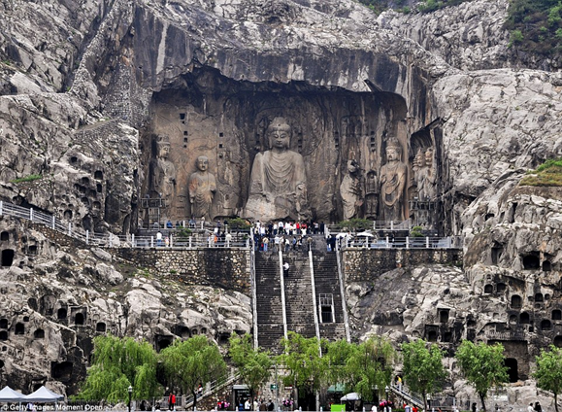

Getty Images/Moment Open

Document 5
Source: Zong Mi, a leading Buddhist scholar, favored by the Tang imperial household, essay, “On the Nature of Man,” early ninth century C.E.

Confucius, Laozi and the Buddha were perfect sages. They established their teachings according to the demands of the age and the needs of various beings. They differ in their approaches in that they encourage the perfection of good deeds, punish wicked ones, and reward good ones; all three teachings lead to the creation of an orderly society and for this they must be observed with respect.

Document 6
Source: Han Yu, leading Confucian scholar and official at the Tang imperial court, “Memorial on Buddhism,” 819 C.E.

Your servant begs leave to say that Buddhism is no more than a cult of the barbarian peoples spread to China. It did not exist here in ancient times.

Now I hear that Your Majesty has ordered the community of monks to go to greet the finger bone of the Buddha [a relic brought to China from India], and that Your Majesty will ascend a tower to watch the procession as this relic is brought into the palace. If these practices are not stopped, and this relic of the Buddha is allowed to be carried from one temple to another, there will be those in the crowd who will cut off their arms and mutilate their flesh in offering to the Buddha.

Now the Buddha was a man of the barbarians who did not speak Chinese and who wore clothes of a different fashion. The Buddha’s sayings contain nothing about our ancient kings and the Buddha’s manner of dress did not conform to our laws; he understood neither the duties that bind sovereign and subject, nor the affections of father and son. If the Buddha were still alive today and came to our court, Your Majesty might condescend to receive him, but he would then be escorted to the borders of the nation, dismissed, and not allowed to delude the masses. How then, when he has long been dead, could the Buddha’s rotten bones, the foul and unlucky remains of his body, be rightly admitted to the palace? Confucius said: “Respect ghosts and spirits, but keep them at a distance!” Your servant is deeply ashamed and begs that this bone from the Buddha be given to the proper authorities to be cast into fire and water, that this evil be rooted out, and later generations spared this delusion.

Document 7
Source: Tang Emperor Wu, Edict on Buddhism, 845 C.E.

We have heard that the Buddha was never spoken of before the Han dynasty; from then on the religion of idols gradually came to prominence. So in this latter age Buddhism has transmitted its strange ways and has spread like a luxuriant vine until it has poisoned the customs of our nation. Buddhism has spread to all the nine provinces of China; each day finds its monks and followers growing more numerous and its temples more lofty. Buddhism wears out the people’s strength, pilfers their wealth, causes people to abandon their lords and parents for the company of teachers, and severs man and wife with its monastic decrees. In destroying law and injuring humankind indeed nothing surpasses this doctrine!

Now if even one man fails to work the fields, someone must go hungry; if one woman does not tend her silkworms, someone will go cold. At present there are an inestimable number of monks and nuns in the empire, all of them waiting for the farmers to feed them and the silkworms to clothe them while the Buddhist public temples and private chapels have reached boundless numbers, sufficient to outshine the imperial palace itself.

Having thoroughly examined all earlier reports and consulted public opinion on all sides, there no longer remains the slightest doubt in Our mind that this evil should be eradicated.

