Period 4 Timed LEQ
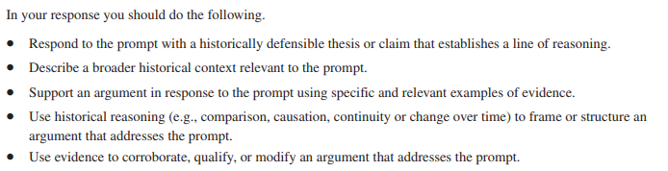

- Using your knowledge of world history analyze continuities and changes in social conditions that occurred in the Atlantic World as a result of new contacts among Western Europe, Africa, and the Americas from 1492 to 1750.

