Period 4 Take Home DBQ
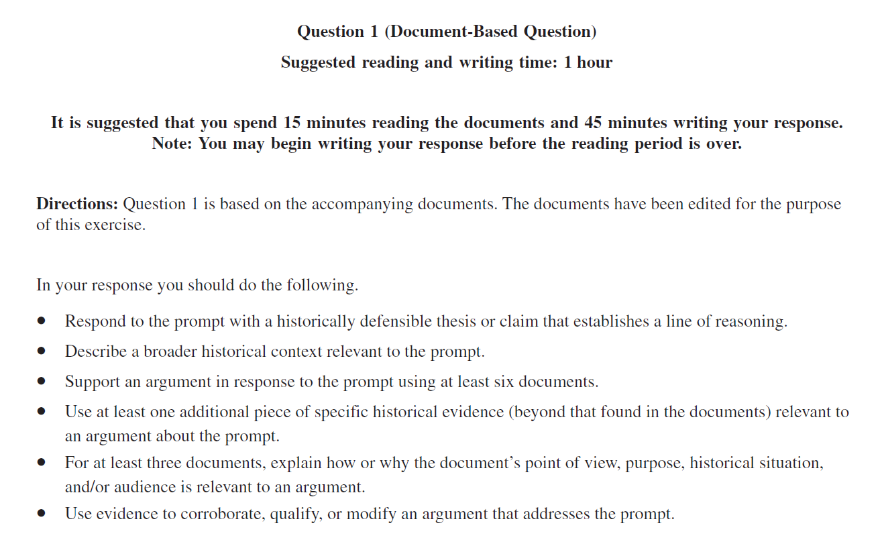

- Evaluate the extent to which the global flow of silver changed societies in the period from 1500 to 1750.

