Period 5 Take Home DBQ
Directions: Question 1 is based on the accompanying documents. The documents have been edited for the purpose of this exercise.
In your response you should do the following.
- Respond to the prompt with a historically defensible thesis or claim that establishes a line of reasoning.
- Describe a broader historical context relative to the prompts.
- Support an argument in response to the prompt using all of the documents.
- For at least three documents, explain how or why the document’s point of view, purpose, historical situation, and/or intended audience is relevant to an argument.
- Use at least one additional piece of specific historical evidence beyond the examples found in the documents.
- Use evidence to corroborate, qualify, or modify an argument that addresses the prompt to create a highly organized and analytical essay that might include one or more of the following techniques:
- Explaining nuance of an issue by analyzing multiple variables
- Explaining both similarity and difference, or explaining both continuity and change, or explaining multiple causes, or explaining both cause and effect
- Explaining relevant and insightful connections within and across periods
- Confirming the validity of an argument by corroborating multiple perspectives across themes
- Qualifying or modifying an argument by considering diverse or alternative views or evidence

Question 1: Using the following documents, analyze the causes and consequences of Latin American independence movements from the late 18th to early 19th century.

Document 1

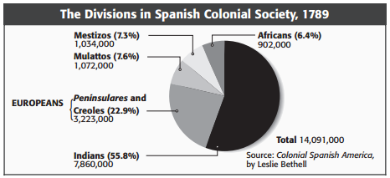
Source: Historian Leslie Bethell, Colonial Spanish America, 1987

*note: Peninsulares=Europeans born in Spain
Creoles= Born in Latin America of European ancestry

Document 2

Source: Unknown Peruvian artist, America Nursing Spanish Noble Boys, ca. 1770s
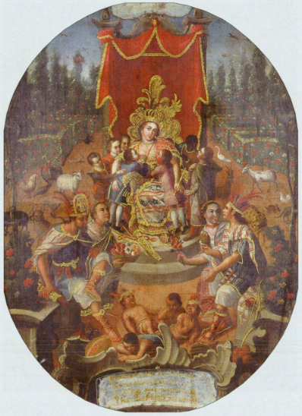

*Note: Spanish text in the banner at the bottom reads:
“Where in the world has one seen what one sees here…her own sons lie groaning and she suckles strangers.”

Document 3

Source: Felipe Fernández-Armesto, The Americas: A Hemispheric History, 2003
“…common notions of popular sovereignty, of the virtues of republicanism and citizenship, of ‘the rights of man and of the citizen,’ of colonial dignity, and of the rule of written constitutions and codified laws around the hemisphere became shared ideas in Spanish and English colonies and the vocabulary of a common, Pan-American discourse. They took flesh and blood in revolutionary wars of independence that between 1776 and 1829 ‘liberated’ the United States and much of the rest of the American mainland. Although the revolutions had very different results, the causes were similar: resentful local elites resisting the growing interference of intrusive governments from their ‘mother countries.’…A ‘creole mentality’-a sense of a difference of interests and perhaps of nature-set the colonists apart from their metropolitan masters and partners and grew markedly in the decade preceding the Declaration of Independence. By ‘creole’ I mean an identity espoused by colonials distinct from that of the mother country.”

Document 4

Source: South American Jesuit-Catholic author Juan Pablo Viscardo, writing from London, An Open Letter to the Americas, 1791
“Spanish restrictions on travel and commerce sealed Latin America off from the rest of the world limiting our basic personal and property rights…We in the Americas are perhaps the first to be forced by our own government to sell our products at artificially low prices and buy what we need at artificially high prices. This is the result of the Spanish commercial monopoly system, combined with high taxes and official fees. And because the official monopoly on transatlantic trade would naturally lead us to produce more in America, the government has been careful to place limitations on what we can legally produce.
Spain could have left us at least the administration of our own affairs, one would think. Americanos, being those most concerned by affairs of America, logically ought to fill the public offices of their own countries for the benefit of all concerned. But that has been far from the case.”

Document 5

Source: Father Miguel Hidalgo, Grito de Delores (the ‘cry’ or speech delivered at the church of Delores, Mexico which launched the Mexican revolution), September 15th, 1810
“My friends and countrymen-Neither the Spanish king nor his tributes exist for us any longer. We have borne this tax, which only suits slaves, for three centuries as a sign of tyranny and servitude, a terrible stain which we shall know how to wash away with our efforts. The moment of our freedom has arrived, the hour of our liberty has struck; and if you recognize its great value, you will help me defend it from the ambitious grasp of the tyrants. Only a few hours remain before you see me at the head of the men who take pride in being free. I invite you to fulfill this obligation. And so without a nation nor liberty we shall always be at a great distance from true happiness…Our cause is holy and God will protect it…Long live then, the Virgin of Guadalupe! Long live America for which we are going to fight!”

Document 6

Source: Francisco Isnardy, et. al., Venezuelan Declaration of Independence, July 5th, 1811
“We, the representatives of the United Provinces of Venezuela, calling on the Supreme Being to witness the justice of our proceedings and the rectitude of our intentions, do implore his divine and celestial help, the desire we have of living and dying free…These united Provinces are, and ought to be, from this day, by act and right, free, sovereign and independent states; and that they are absolved from every submission and dependence on the throne of Spain, and that a free and independent state, thus constituted, has full power to take that form of government which may be conformable to the general will of the people.”

Document 7

Source: South American Revolutionary Leader Simon Bolivar, Independence Address, 1815
“Success will crown our efforts because the destiny of Latin America is irrevocably fixed; the tie that bound her to Spain is severed. The hatred we feel for the Peninsula is greater than the sea separating us from it…We are not Europeans; we are not Indians. Latin Americans by birth and Europeans by law, we find ourselves engaged in a dual conflict: We are disputing with natives for titles of land ownership, and at the same time we are struggling to maintain ourselves in the country that gave us birth against the opposition of Spanish invaders. Thus our position is most extraordinary and complicated.”

