Period 4 Practice Document-Based Question
Directions: Question 1 is based on the accompanying documents. The documents have been edited for the purpose of this exercise.

In your response you should do the following:
- Respond to the prompt with a historically defensible thesis or claim that establishes a line of reasoning.
- Describe a broader historical context relevant to the prompt.
- Support an argument in response to the prompt using at least six documents.
- Use at least one additional piece of historical evidence (beyond that found in the documents) relevant to an argument about the prompt.
- For at least three documents, explain how or why the document’s point of view, purpose, historical situation, and/or audience is relevant to an argument.
- Use evidence to corroborate, qualify, or modify an argument that addresses the prompt.

1. Using the documents, and your knowledge of world history, analyze the social and economic effects of the global flow of silver from 1500 to 1750.

Question 1: Using the documents, and your knowledge of world history, evaluate the extent of social and economic effects of the global flow of silver from 1500 to 1750CE.

Document 1
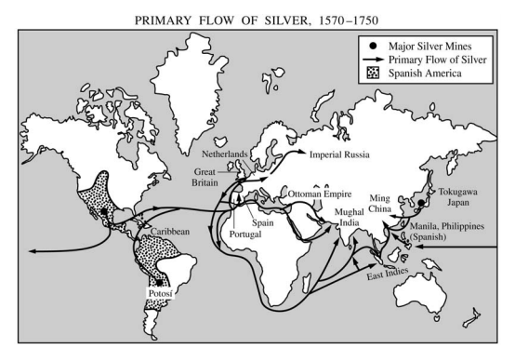

Document 2
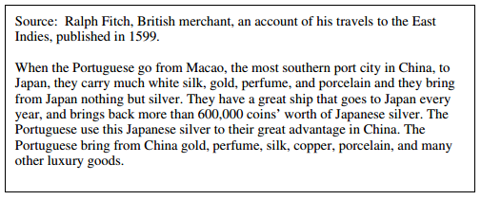

Document 3
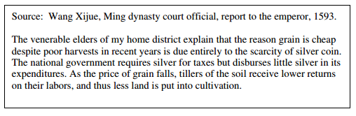

Document 4
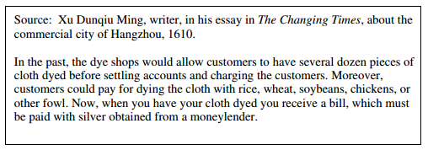
Document 5
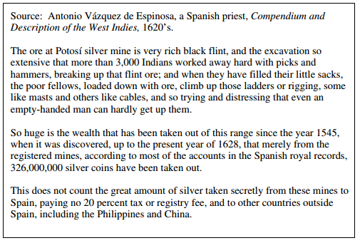
Document 6
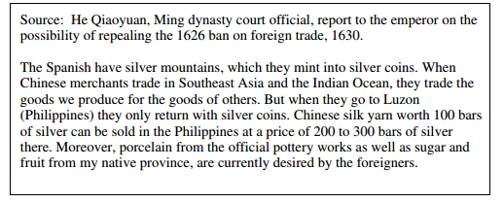

Document 7
