Revolutionary Era Study Guide
1. Who was the former slave who organized a revolution in Haiti?

2. Who was the military general who crowned himself emperor of France?

3. What is the definition of nationalism?

4. Why did Napoleon go to war against most of Europe?

5. What was the goal of the Reign of Terror?

6. When Britain, Austria, Prussia, and Russia met at the Congress of Vienna after Napoleon’s defeat, what were their goals?

7. What sparked widespread revolt in Latin America in the early 1800s?

8. What was the cause of the Haitian Revolution?

FRANCE LATIN AMERICA
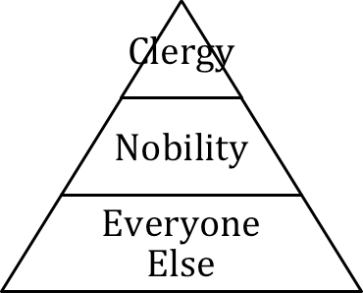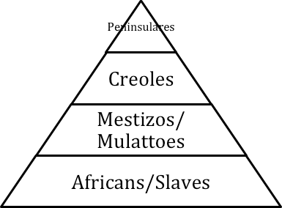

9. Using the charts above, how did political revolutions change social order in France and Latin America?

10. Name the political, economic, and social causes of the French Revolution.
-Political:

-Economic:

-Social:

11. Explain how the French Revolution inspired other revolutions around the world.

