AP World History
Sourcing Strategies

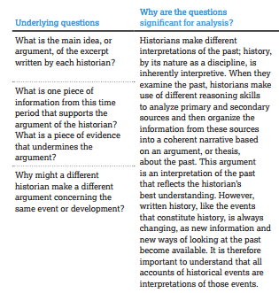
Sourcing is important when confronting any document. You will need to source information from documents in both free response questions and in stimulus-based multiple-choice questions. An easy acronym to remember to source documents is through HIPP. HIPP Stands for Historical Context, Intended Audience, Purpose, and Point of View. You should also consider the sourcing strategies below that will be effective in a variety of ways for both primary and secondary sources.
