Test Overview

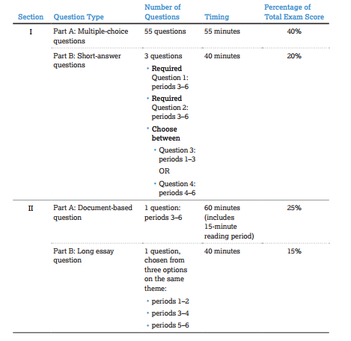
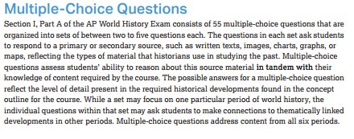
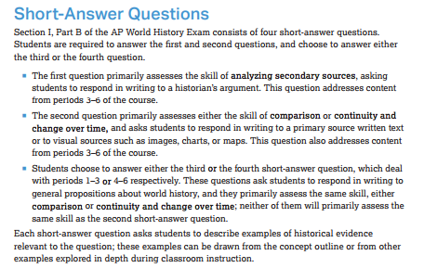
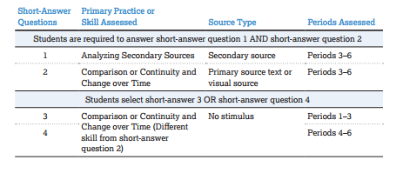
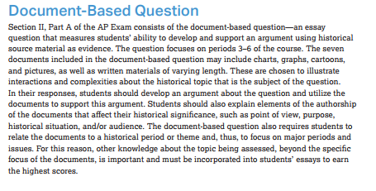
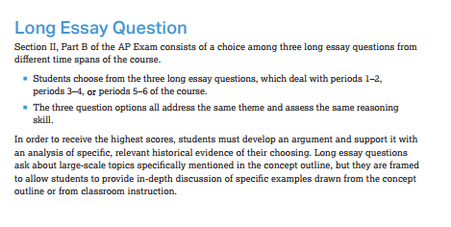
Periods On Test
LEQ Options:
1 Option Periods 1-2
1 Option Periods 3-4
1 Option Periods 5-6

DBQ Options:
No Options, 1 Choice Periods 3-6

SAQ Options:
No Option Q1 Analyzing Secondary Sources, Secondary Source, Periods 3-6
No Option Q2 Comp or CCoT, Primary Source Text or Visual, Periods 3-6
Options Q3-Q4 Comp or CCoT, No Stimulus, Q3 Periods 1-3, Q4 Periods 4-6

MCQ:
All Periods
See Periodization percentage chart

