AP World History
Course Preparation Assignment

Welcome to AP World History for the 2018-19 school year! Advanced Placement World History is a thematic, college-level course designed to familiarize you with the broad patterns of the human experience. You will concentrate on change and continuity over time, the unique aspects of social, economic and political institutions, and the common characteristics that tie them together. You are now charged with the role of a historian and will engage in activities that encourage critical thinking and hone your ability to debate established historical interpretations and express your educated views using primary source documents. Throughout the year, you will actively compare cultures and look for historical patterns that stretch across time periods and ties all human populations together through history.

The primary purpose of this packet is to help you acquire the base knowledge necessary for instant immersion in AP World History at the beginning of the 2018-19 academic year.

THIS ASSIGNMENT IS DUE ON FRIDAY, AUGUST 24TH

A Special Note about Plagiarism: Plagiarism, the act of taking credit for the academic work of someone else, will not be tolerated in AP World History and Bellevue West High School.

AP WORLD HISTORY PREPARATION ASSIGNMENT
Part 1: Mapping Exercise
Neatly label the world maps with the land and water features listed below in the color indicated in parentheses. Print neatly and make sure your maps are easy to read. Fill-in maps are found at the end of the packet.

Map #1: Bodies of Water and Rivers
Oceans, Seas, Bays, Lakes (color them blue) Rivers (draw them in blue)
1. Atlantic Ocean 1. Nile River
2. Pacific Ocean 2. Tigris River
3. Indian Ocean 3. Euphrates River
4. Arctic Ocean 4. Amazon River
5. North Sea 5. Mississippi River
6. Baltic Sea 6. Rio Grande River
7. English Channel 7. Indus River
8. Norwegian Sea 8. Yangtze River
9. Barents Sea 9. Yellow River (Huang He)
10. Mediterranean Sea 10. Irrawaddy River
11. Adriatic Sea 11. Mekong River
12. Aegean Sea 12. Ganges River
13. Black Sea 13. Congo River
14. Caspian Sea 14. Danube River
15. Great Lakes 15. Niger River
16. Red Sea
17. Persian Gulf
18. Arabian Sea
19. Bay of Bengal
20. South China Sea
21. Yellow Sea
22. Sea of Japan

Map #2: Mountains and Deserts
Mountains (brown) Deserts (yellow)
1. Alaska Range 1. Gobi Desert
2. Rocky Mountains 2. Kalahari Desert
3. Appalachian Mountains 3. Sahara Desert
4. Alps 4. Thar Desert
5. Atlas Mountains 5. Mojave Desert
6. Ural Mountains 6. Namib Desert
7. Andes Mountains 7. Syrian Desert
8. Hindu Kush
9. Himalaya Mountains

Map #3: AP World Regions
Refer to the world regions maps attached. Using the map provided, draw and label the AP Regions based on the “closer view”. You may color it if you would like but that is not a requirement. However, please use a color or striping to indicate regions that overlap.

Part 2: Common World History Vocabulary
Below you will find a chart of vocabulary words that will be repeated over and over during the course. These words will apply to many different cultures and eras throughout history. It is important that you become familiar with the words and their meanings. Your definitions should be hand-written and in complete sentences that thoroughly explain the word as it relates to the study of World History. Resources to find these definitions include online and hard copy dictionaries. There may be more than one definition for a term, make certain to use the historical definition that would be in line with this history class.

Absolutism
Agriculture
Afro-Eurasia

Analyze

Aristocracy
Bias
Bureaucracy
Chiefdom
City-State
Civilization
Commercial
Continuity

Contextualization

Demography
Divination
Dynasty
Empire
Epidemic
Forager
Globalization
Indentured Servant
Interregional
Intraregional

Kingdom
Medieval
Merchant
Mesoamerica

Monotheism
Nation-State

Polytheism

Primary Source
Revolution
Rural
Scribe
Secondary Source
Serf
Shaman
Slave
State
Steppes
Theocracy

Urban

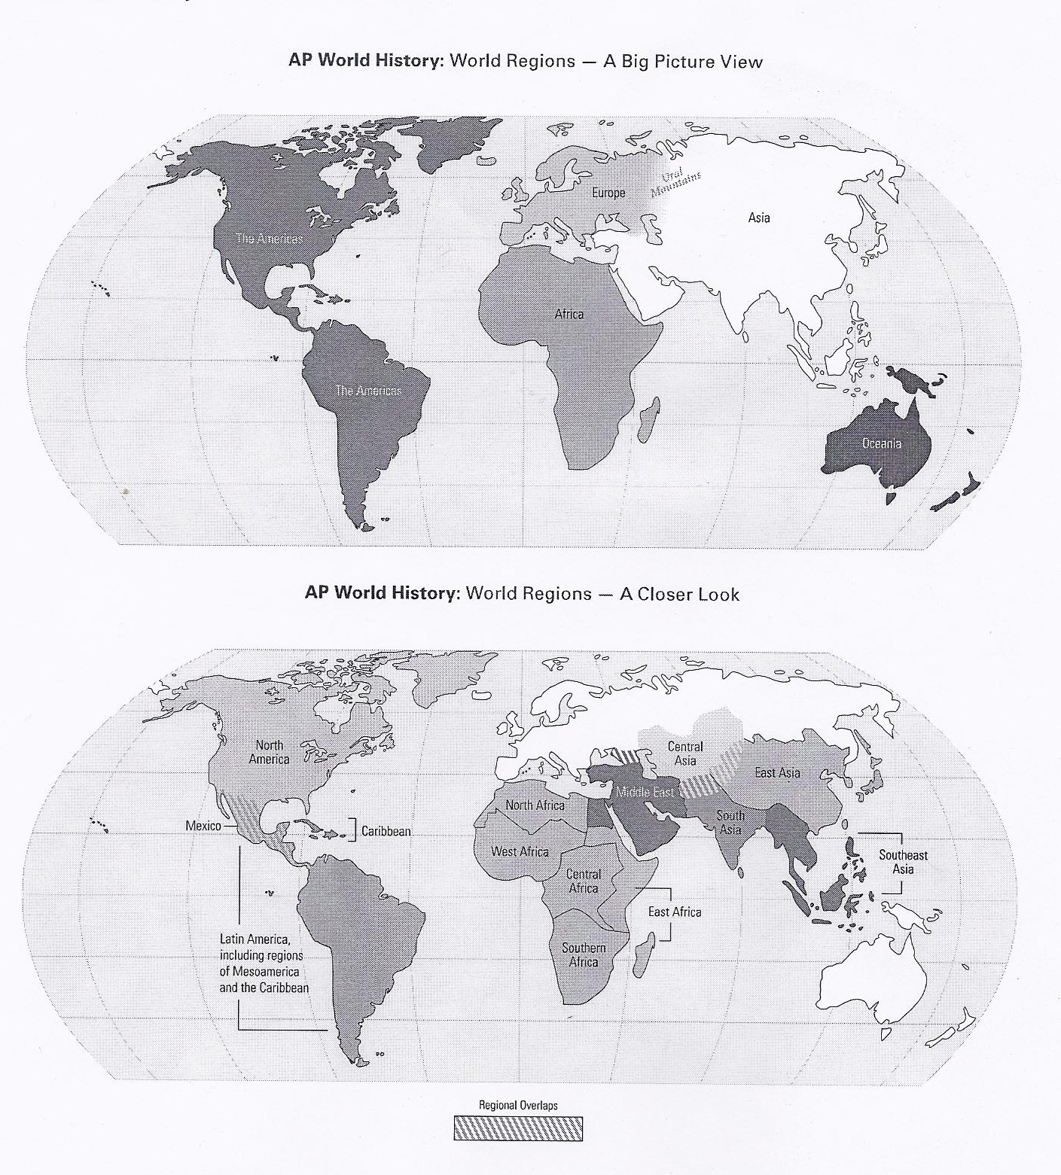

Fill-In Map #1 - Bodies of Water and Rivers

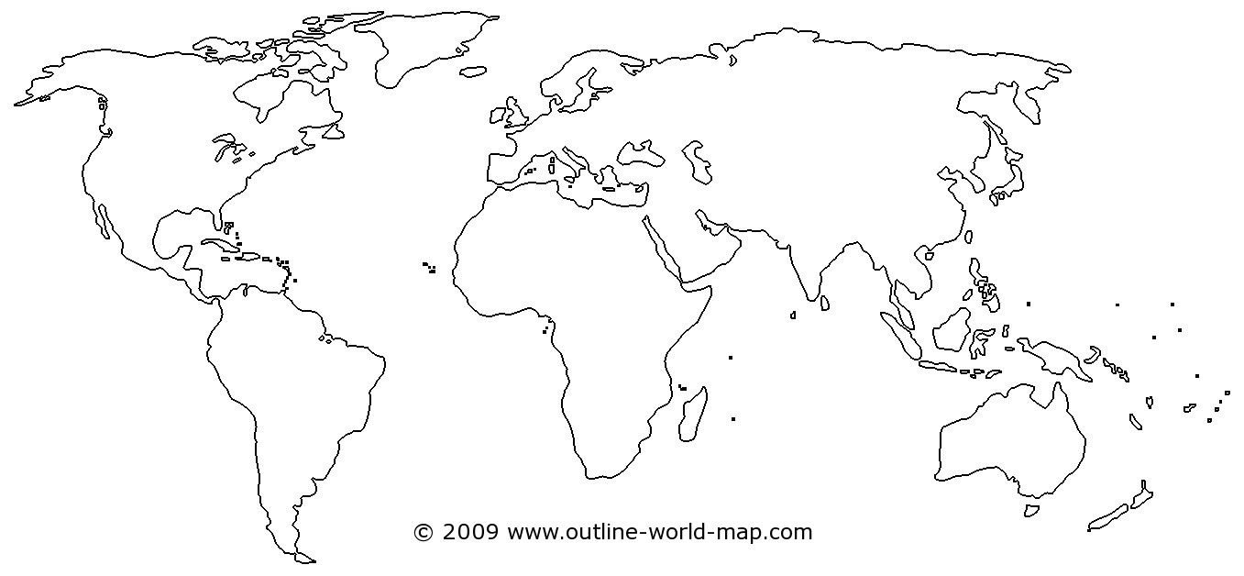

Fill-In Map #2 – Mountains and Deserts

Fill-In Map #3 - AP World Regions

