SUMMER ASSIGNMENT 2017
AP WORLD HISTORY
Mr. Torrez and Mrs. Thiessen

Dear Students –

Welcome to AP World History for the 2017-18 school year! Advanced Placement World History is a thematic, college-level course designed to familiarize you with the broad patterns of the human experience. You will concentrate on change and continuity over time, the unique aspects of social, economic and political institutions, and the common characteristics that tie them together. You are now charged with the role of a historian and will engage in activities that encourage critical thinking and hone your ability to debate established historical interpretations and express your educated views using primary source documents. Throughout the year, you will actively compare cultures and look for historical patterns that stretch across time periods and ties all human populations together through history.

The primary purpose of this summer assignment is to help you acquire the base knowledge necessary for instant immersion in AP World History once the 2017-18 academic year begins. There will be two items you are turning in: 1) This packet which contains the maps, vocabulary charts and PIRATES charts; 2) Your typed or hand-written comparison essay on a separate sheet of paper.

THIS SUMMER ASSIGNMENT IS DUE ON THE FIRST DAY OF SCHOOL FOR ALL STUDENTS–
FRIDAY, AUGUST 11TH

Late assignments will not be accepted. It is important that you show you are capable of successfully completing this independent assignment in the time allotted. The only exception will be those students that enrolled new to our school in August. Anyone that registered prior to that date will be expected to have the assignment completed by the first day of school.

A Special Note about Plagiarism: Plagiarism, the act of taking credit for the academic work of someone else, will not be tolerated in AP World History and Bellevue West High School.

If you have any questions regarding this assignment, please contact both teachers below.

Teacher: Mr. Torrez Teacher: Mrs. Thiessen
E-mail: james.torrez@bpsne.net E-mail: alexandra.thiessen@bpsne.net
Website: sites.google.com/a/bpsne.net/torrez-website/ Website: mrsthiessensclass.weebly.com

AP WORLD HISTORY SUMMER ASSIGNMENT
Part 1: Mapping Exercise
Neatly label the world maps with the land and water features listed below in the color indicated in parentheses. Print neatly and make sure your maps are easy to read. Fill-in maps are found at the end of the packet.

Map #1: Bodies of Water and Rivers
Oceans, Seas, Bays, Lakes (color them blue) Rivers (draw them in blue)
1. Atlantic Ocean 1. Nile River
2. Pacific Ocean 2. Tigris River
3. Indian Ocean 3. Euphrates River
4. Arctic Ocean 4. Amazon River
5. North Sea 5. Mississippi River
6. Baltic Sea 6. Rio Grande River
7. English Channel 7. Indus River
8. Norwegian Sea 8. Yangtze River
9. Barents Sea 9. Yellow River (Huang He)
10. Mediterranean Sea 10. Irrawaddy River
11. Adriatic Sea 11. Mekong River
12. Aegean Sea 12. Ganges River
13. Black Sea 13. Congo River
14. Caspian Sea 14. Danube River
15. Great Lakes 15. Niger River
16. Red Sea
17. Persian Gulf
18. Arabian Sea
19. Bay of Bengal
20. South China Sea
21. Yellow Sea
22. Sea of Japan

Map #2: Mountains and Deserts
Mountains (brown) Deserts (yellow)
1. Alaska Range 1. Gobi Desert
2. Rocky Mountains 2. Kalahari Desert
3. Appalachian Mountains 3. Sahara Desert
4. Alps 4. Thar Desert
5. Atlas Mountains 5. Mojave Desert
6. Ural Mountains 6. Namib Desert
7. Andes Mountains 7. Syrian Desert
8. Hindu Kush
9. Himalaya Mountains

Map #3: AP World Regions
Refer to the world regions maps attached. Using the map provided, draw and label the AP Regions based on the “closer view”. You may color it if you would like but that is not a requirement. However, please use a color or striping to indicate regions that overlap.

Part 2: Common World History Vocabulary
Below you will find a chart of vocabulary words that will be repeated over and over during the course. These words will apply to many different cultures throughout history. It is important that you become familiar with the words and their meanings. You definitions should be hand-written and in complete sentences that thoroughly explain the word as it relates to the study of World History. Resources to find these definitions include online and hard copy dictionaries. There may be more than one definition for a term, make certain to use the historical definition that would be in line with this history class.

Absolutism
Agriculture
Aristocracy
Bias
Bureaucracy
Chiefdom
City-State
Civilization
Commercial
Demography
Divination
Dynasty
Empire
Epidemic
Forager
Globalization
Indentured Servant
Interregional
Kingdom
Medieval
Merchant
Monotheism
Primary Source
Revolution
Rural
Scribe
Secondary Source
Serf
Shaman
Slave
State
Steppes
Urban
Part 3: PIRATES Charts
Throughout this course you will be asked to break down cultures and civilizations to a basic level that will allow you to recognize the MOST important characteristics and easily compare one civilization with another. A PIRATES chart will be used throughout the course to analyze civilization/culture in seven components. We will also have comparison charts that will be used to show similarities between multiple civilizations/cultures. For this summer, use the Internet or other resources and analyze each of the following civilizations. Complete the following PIRATES charts for each civilization listed. Include specific and general information (minimum of 5 bullet statements per topic).

Explanation of PIRATES categories:
The ability to sort information into categories is an essential skill for AP World History students. Listed below are the common categories that we will utilize. They relate to the 5 themes of AP World History.

Political
- Having to do with gaining, seeking, and organizing power
- Events related to the function of government: making laws, enforcing laws, and interpreting laws

Interaction with Environment
- Having to do with how the environment shaped human societies and how humans shaped the environment
- Including such issues as demography, disease, migration, patterns of settlement, and environmental technology

Religious
- Having to do with religious beliefs, whether organized or traditional
- The religious institutions of culture

Art and Architecture
- Having to do with art (visual, musical, written) and architecture as well as intellectual movements/philosophy

Technology
- Having to do with the technology, tools, and inventions used by the society

Economic
- Having to do with how people meet their basic material needs
- The production, distribution and consumption of goods and services
- Including such issues as domestic and international trade, monetary policies and taxation

Society
- Having to do with people in groups, their living together, and relations with one another
- Includes such issues as: gender, economic status and ethnicity

PIRATES Chart
Mesopotamia
Tigris and Euphrates River Valley
POLITICS

INTERACTION WITH ENVIRONMENT
RELIGION
ARTS AND ARCHITECTURE
TECHNOLOGY
ECONOMY
SOCIETY
PIRATES Chart
Ancient Egypt
Old and New Kingdoms (Nile River Valley)
POLITICS

INTERACTION WITH ENVIRONMENT
RELIGION
ARTS AND ARCHITECTURE
TECHNOLOGY
ECONOMY
SOCIETY
Part 4: Comparison Essay
One type of essay that you will be asked to write on the AP World History exam is a long-essay question. There are several types of long-essay question including comparison, causation, continuity and change over time, and periodization. For practice, you will write a comparison long-essay question. This is a style of essay that will compare to societies or civilizations in a given time frame. We do not expect a perfect essay but we do expect full effort given. Essays will have a minimum of five paragraphs with a clear thesis that directly compares the two civilizations. By completing this essay, we will have a chance to understand your writing ability as we begin the class and you will have a chance to practice one of the essay structures we will focus on for the AP exam. Final essays should be typed or neatly hand-written and turned in on a separate sheet of paper on the first day of school. Please see the attached rubric and resources as a guideline for your essay.

**Essay Prompt:**
Compare and contrast the economic, political, and social aspects of the ancient civilizations of Mesopotamia and Egypt.

AP World History Comparative Essay Generic Rubric Overview
Long-Essay Rubric- Targeted Skill: Comparison
A. Thesis (1 Point)
Presents a thesis that makes a historically defensible claim and responds to all parts of the question. The thesis must consist of one or two sentences located in one place, either in the introduction or the conclusion.
B. Argument Development: Using the Targeted Historical Thinking Skill (2 Points)
Comparison:
1 Point describes similarities and differences among historical individuals, events, developments, or processes.
1 Point explains the reasons for similarities and differences among historical individuals, events, developments or processes. Or, evaluates the relative significance of historical individuals, events, developments, or processes.
C. Argument Development: Using Evidence (2 Points)
1 Point addresses the topic of the question with specific examples of relevant evidence.
1 Point utilizes specific examples of evidence to fully and effectively substantiate the stated thesis or a relevant argument.
D. Synthesis (1 Point)
1 Point extends the argument by explaining the connections between the argument and ONE of the following:
a. A development in a different historical period, situation, era, or geographical area.
b. A course theme and/or approach to history that is not the focus of the essay (political,
economic, social, cultural, or intellectual history).
c. A different discipline or field of inquiry (economics, government, politics, art history,
anthropology).
Subtotal 6 Points

SUGGESTED RESOURCE CHART: COMPARE & CONTRAST TWO CIVILIZATIONS

THESIS

 | Mesopotamia | Egypt | Key  Similarities and Differences | Analyze one reason  why each theme is similar/different
Economic Aspects

Political Aspects

Social Aspects

CONCLUSION

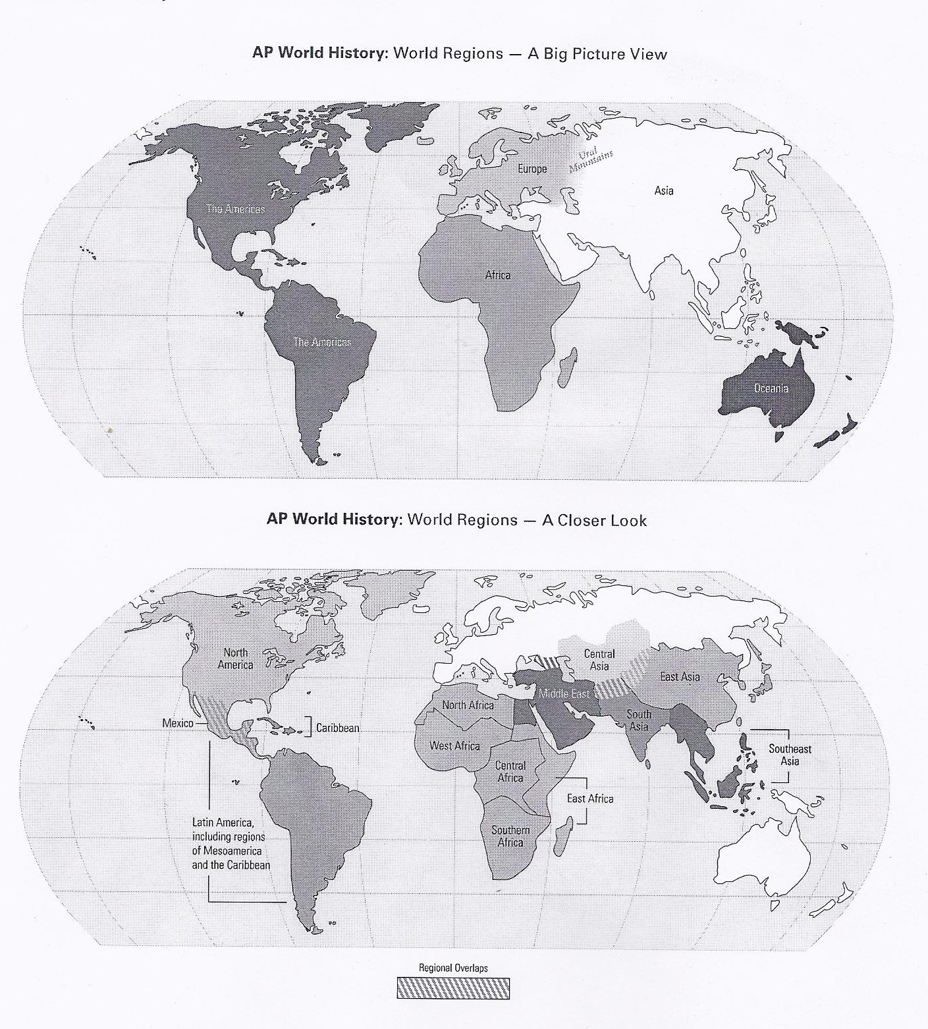

Fill-In Map #1 - Bodies of Water and Rivers

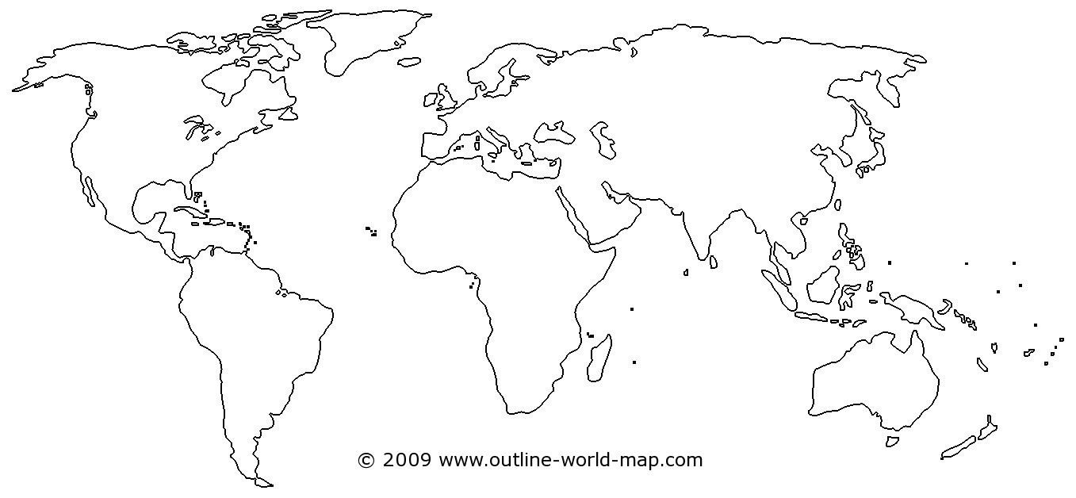

Fill-In Map #2 – Mountains and Deserts

Fill-In Map #3 - AP World Regions

